Feasibility Study & Discovery Workshop

PLANNER FOR A SUCCESSFUL APPLICATION

by

mDevelopers
INFO

This document aims to formulate your idea, scope, and plan for an application in 7 steps.

All this using tasks and carefully designed questions that we often use at our Feasibility Study and Discovery Workshop. Their help in designing a plan for a digital product is invaluable. See for yourself!

*TIP*
It is worth filling out this document to avoid misunderstandings at later stages. When working with your team assigned to the project, complete the tasks and use our questions. Write out answers that vary to see which departments don't quite understand the assumptions and answer the unanswered questions. If everything is consistent then great and go to the next step! If you will need any help you can contact us via mail: office@mdevelopers.com or https://mdevelopers.com/free-consultation
TABLE OF CONTENT

1. Product vision and purpose
2. *Target audience - User personas
3. *User flows - Basic overview
4. *User stories
5. Prioritized functionality
6. Frameworks and tech stack
7. Budget and Timeline

Product vision and purpose
The first step should always be to find the product vision and its purpose/goals. During our workshops, we do it to familiarize ourselves with the client's project and find answers to questions on which the project will be based. You can also go through this stage to see if the initial assumptions are understood by your team and all important issues are discussed.

QUESTION | ANSWER
What problem does our project focus on?
What is the solution and why exactly is that?
What are the main objectives of our project?
What is the overall description of our project?
What are the main business goals of the application?
What will be the approach to solving the problem we are focusing on?
What are the Success Criteria?
IF THERE IS A COMPETITOR ON THE MARKET
What are his strengths?
What are his weaknesses?

2. *Target audience - User personas

*This step is only a preliminary version and should be developed during the UX workshop

Knowing what your end-user will look like is one of the most important pieces of information you need to have to build a successful product. Answer the following questions to create a profile of your ideal end-user.

Overview
QUESTION | ANSWER
What is his/her job?
What is his/her industry, and his/her role in it?
Goals
QUESTION | ANSWER
What are his/her responsibilities in his/her job?
How does he/she define progress/success in his/her job? How does he/she measure progress/success?

Attitudes & Motivations
QUESTION | ANSWER
What are the most enjoyable parts of his/her job? What does he/she value most?
Are there any external (extrinsic) or Internal (intrinsic) motivations to do a good job? (such as rewards, promotions, perks, etc…)

Processes

QUESTION | ANSWER
What does his/her typical workday look like?
How does he/she do [a certain task]?

How long does this task typically take?
Where would he/she start?
What would he/she do next?
Can you show me how he/she does that?

What activities take up most of his/her time?

What activities are most important to his/her success?
Are there any company or industry-mandated processes/tasks?

Pain Points

QUESTION | ANSWER
What are the most difficult/challenging/annoying/frustrating aspects of his/her job?

Tools and technology

QUESTION | ANSWER
What traditional (analog) tools does he/she use to accomplish tasks in his/her job?
What digital tools does he/she use to accomplish tasks in his/her job?
Where do any of your tools fall short? (What doesn’t it do (or do well) that you need it to do?)

Organizational Structure

QUESTION | ANSWER
Besides clients/customers, who else does he/she interact with while doing his/her work?
Who does he/she report to? Who reports to his/her?
How often does he/she collaborate with others? How does he/she collaborate?

3. *User flows - Basic overview

*This step is only a preliminary version and should be developed during the UX workshop

User flow is the path taken by a prototypical user on your website or app to complete a task. The user must take them from their entry point through all of the steps towards achieving success and finally clicking that final button. Designing these flows should be one of the top priorities for making sure users are able to achieve what they need without hiccups along the way! Start by answering the below questions.

QUESTION | ANSWER
Could you determine your users’ objectives?
What information do your users need to decide?
Where and when they should get this information?
What the most important user flow should look like?

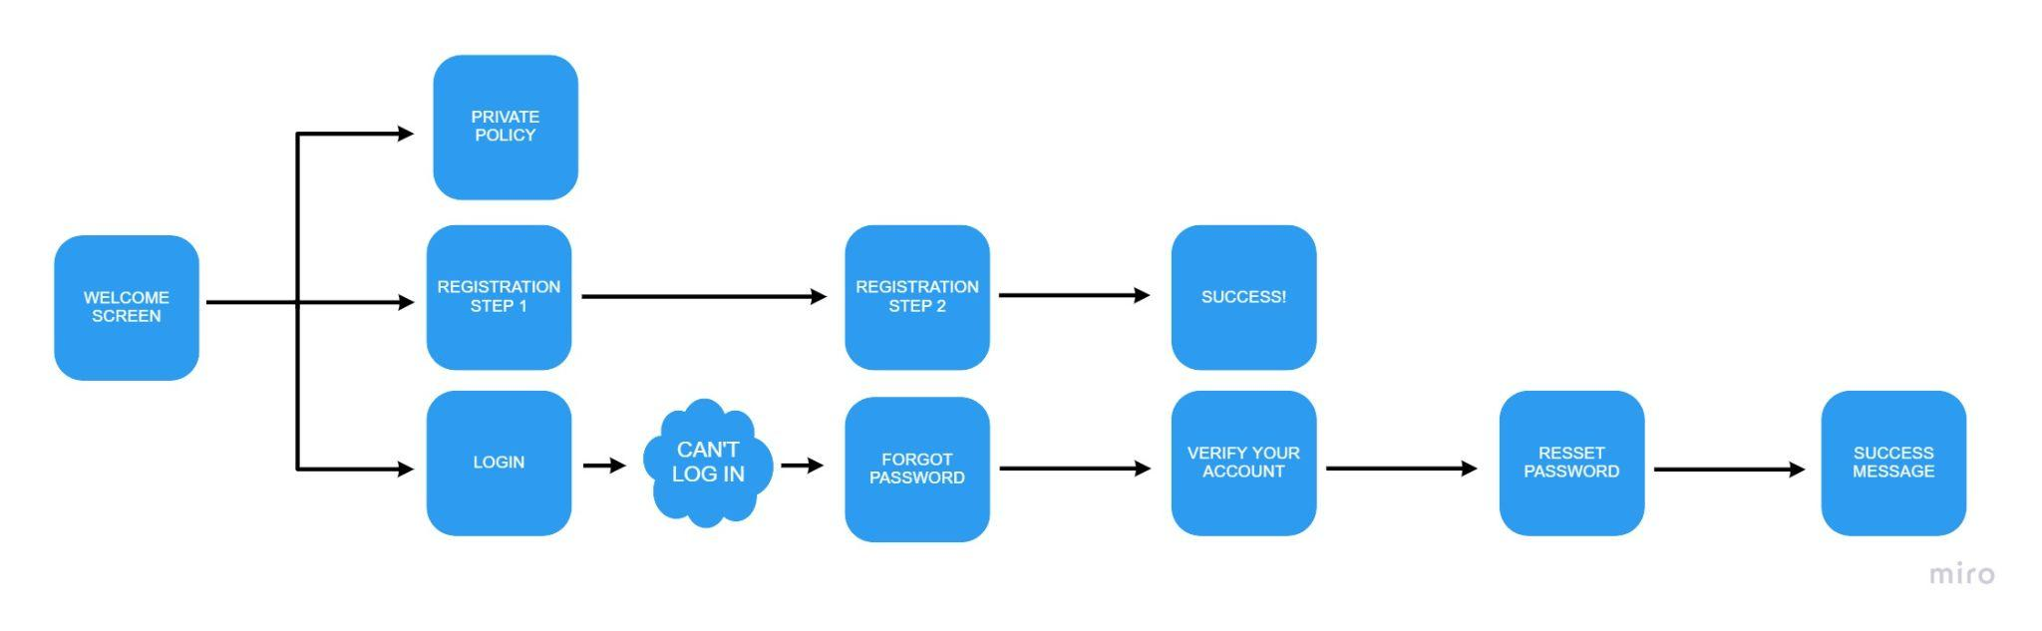
And now with help of answered questions try to design user flow yourself! Remember that you should do a user flow for each objective the user wants to achieve. Here is an example of how it should look like ↓

As you see even such a process as login/ registration can be a pretty complicated one. To create user flow you can use tools such as miro, which we used to do this example!

4. *User stories

*This step is only a preliminary version and should be developed during the UX workshop
User stories are a technique for describing the requirements of software development in agile methodologies. Most often they are written from the end-user perspective, and their language is simple and understandable to everyone (both technical and non-technical persons).

A typical story is written according to this template:
As <user>, I want <need> that will allow me <goal>.

Examples of user stories that you can supplement can be found below, but it is best if you and the entire team responsible for the product write your own individual user stories here. For instance, let’s say you have a car dealership app. Thanks to user stories, you will know what functionalities should be added to your application so that the previously defined target persona is satisfied.

As a {student}, I want {to research cars in my area} so that I {can find the cheapest one}.
* it shows us that a price filter has to be included *

As a {mother}, I want {to find a comfy little sedan} so that I {can ride my kids to school}.
* it shows us that the choice of car type has to be taken into account *

As a {dealership manager}, I want {to sell cars quickly} so that I {can earn money}.
* it shows us that you need to take into account the paid, higher-ranking offers *

Pain | Need | Gain
No barber database | Researching cheap barbers | Founding the cheapest one and instantly book an appointment

5. Prioritized functionality
In the previous step, you determined what functionalities will be needed in your product. When building a digital product, you need to create a priority list of these functionalities, so that the first release does not turn out that the application has too few of them and the user will go to the competition or have too many of them and the user will get lost.
Answer the following questions to structure your functionality.

*TIP* If you are creating an MVP, use only the most important functionalities, it will save you both time and money.
*TIP* If you are not a technical person, find someone to help (programmer, software company, technical co-founder, CTO, etc.)

QUESTION | ANSWER
What are the most important functionalities in your system?
Which of them are crucial?
Are there any other functionalities that will be necessary?
Are there any unnecessary functionalities?

6. Frameworks and tech stack
If all the previous steps are complete, it's time to move on to the technological aspects. Answering the following questions will help you choose both the tech stack and architecture.

6a. Tech stack

QUESTION | ANSWER
On what devices the system should be available?
Should it be available in apple/google stores?
What payment methods should be available?
What integrations with external systems will be needed?
Should the system be connected to other systems?
Do they have an API?

6b. Architecture

QUESTION | ANSWER
How many users will use the system?
What will the system load be?
How may this number change over the years?
What security standards do we need to ensure?
Will new components of the system be added in the future, e.g. new user interfaces, new modules, new functionalities?
What should you put the greatest emphasis on? (security, availability, scalability, cost of maintenance)

7. Budget and Timeline

If you have completed all 7 steps, you have a document that describes your project well. Now you can go to the vendor who will define your budget and timeline, you can also send a document to us at office@mdevelopers.com and we’ll welcome you to our 2h Complimentary Discovery Workshop!

